# **Lecture #5** - enum - namespaces - typedef

# - Recursion - Runtime stack - Activation record - Tracing a recursive function

**Enumeration type** - C++ allows programmers to create new data types.

* **enum** (Reserved word) - A user-defined data type whose domain is an ordered set of

literal values expressed as identifiers.

Ex #25: Define a new data type: colors (Semicolon)

enum colors { BROWN**,** BLUE**,** RED**,** GREEN**,** YELLOW }**;**

By default, identifiers represent an ordered set of values.

* + - Separate values with a comma.
    - Each identifier has a default integer value. - BROWN = 0

- BLUE = 1

- RED = 2

- GREEN = 3

- YELLOW = 4

* + - ***colors*** is the name of the enumeration (new data type)
    - BROWN becomes a symbolic constant with a value of 0, BLUE = 1, etc.
    - The values (BROWN, BLUE, etc.) are in order: BROWN < BLUE

Ex #26: enum grades {‘A’, ‘B’, ‘C’, ‘D’, ‘F’}; 🡨 Wrong – Values must

be identifiers.

Ex #27: enum grades { A, B, C, D, F }; 🡨 Correct

Ex #28: enum days {SUN, MON, TUES, WED, THU, FRI, SAT};

**Variable Declaration and Assignment of Enumeration type**

Ex #29: (Usually declare enum type global)

enum sports { BASKETBALL, FOOTBALL, SOCCER, BASEBALL };

int main( )

{

sports popularSport;

sports mySport = FOOTBALL;

popularSport = BASEBALL;

_____________________________________________________________________________________________________________

Ex #30: enum days {SUN, MON, TUES, WED, THU, FRI, SAT};

days payDay; // Declare a variable called payDay of type **days**.

payDay = FRI;

Ex #31: (Another way to declare variables)

* + - ***change*** and ***usCoins*** are variables of type coins

enum coins {PENNY, NICKEL, DIME, QUARTER, HALF} change, usCoins;

**Operations on Enumeration Type**

* No math operations on the enumeration type

Ex #32: popularSport = mySport + 1; 🡨 Wrong

* Comparison operations can be done. (Relational operators)
  + Enumeration type is an ordered set of values, so relational operators can be used.

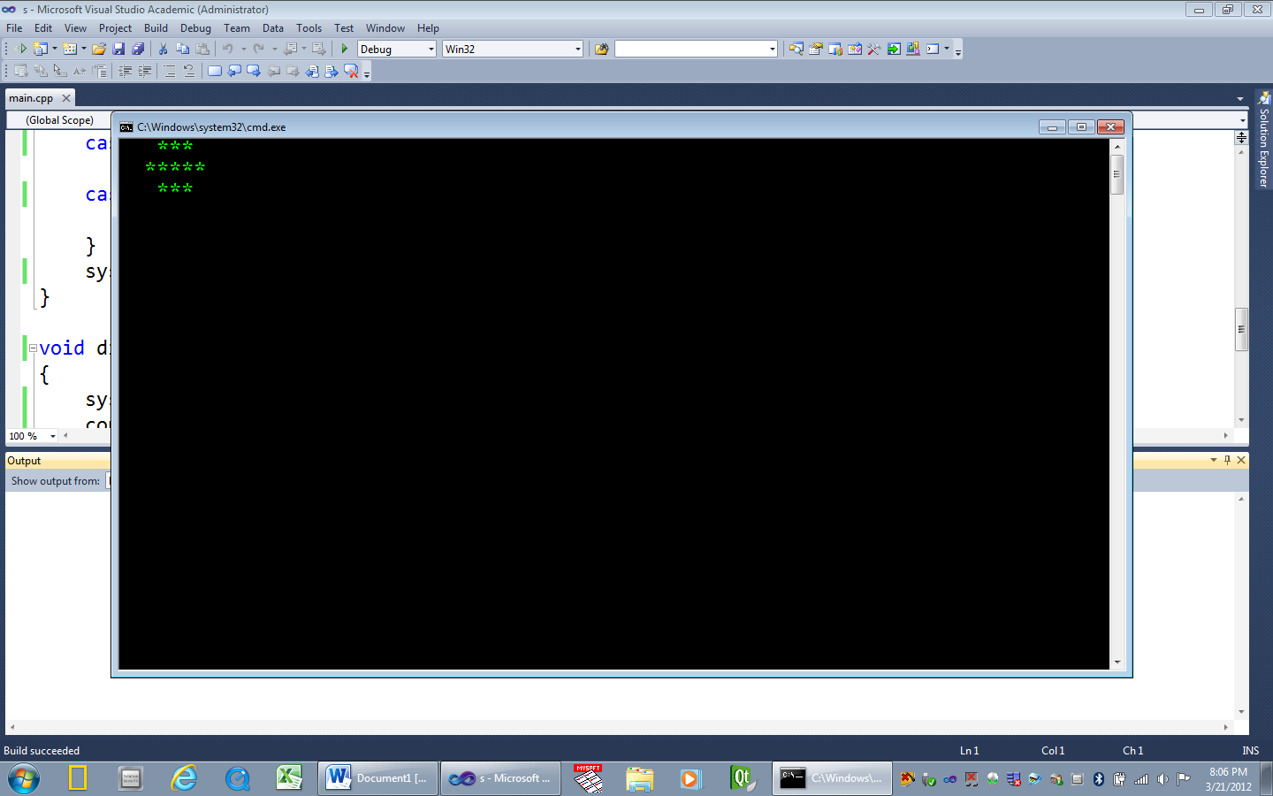Ex #33: if (mySport == yourSport) 🡨 OK

**Exercise: enum trafficLights**

#include <iostream>

#include <string>

#include <Windows.h>

using namespace std;

enum trafficLights { GREEN = 1, YELLOW = 2, RED = 4 };

void setTrafficLight(trafficLights bulbColor);

void displayLight(const char * color);

int main()

{

trafficLights bulbColor = RED; // Start with a red light

setTrafficLight(bulbColor);

bulbColor = GREEN; // Change to a green light

setTrafficLight(bulbColor);

bulbColor = YELLOW; // Change to a yellow light

setTrafficLight(bulbColor);

bulbColor = RED; // Change to a red light

setTrafficLight(bulbColor);

cout << endl;

system("pause");

return 0;

}

void setTrafficLight(trafficLights bulbColor)

{

switch (bulbColor)

{

// Font colors: A = green; C = red; E = yellow; - 0 = black bg

case GREEN: displayLight("Color 0A");

break;

case YELLOW: displayLight("Color 0E");

break;

case RED: displayLight("Color 0C");

break;

}

system("cls");

}

// --------------------------------------------------------------

void displayLight(const char * color)

{

system(color);

cout << " *** \n"

<< " ***** \n"

<< " *** \n";

Sleep(2000);

}

**Namespace** - C++ supports the use of namespaces.

* **Namespace** - A namespace allows entities like classes, objects and functions to be

grouped together under a name.

The format of namespaces is:

namespace identifier

{

entities

}

Ex #34: namespace first

{

int var = 5;

}

* To use a variable (or object or function) defined in a namespace, prefix the variable with

the namespace name and scope resolution operator **::**

Ex #35: cout << first::var; // Output: 5

Ex #36: #include <iostream>

using namespace std;

namespace first

{

int var = 5;

}

namespace second

{

double var = 3.1416;

}

int main()

{

cout << first::var << endl;

/* OUTPUT:

5

3.1416 */

cout << second::var << endl;

return 0;

}

* **using** - The keyword *using* is used to introduce a name from a namespace into the

current declarative region. For example:

Ex #37:

#include <iostream>

using namespace std;

namespace first

{

int x = 5;

int y = 10;

}

namespace second

{

double x = 3.1416;

double y = 2.7183;

}

int main ()

{

**using** **first::x;**

**using second::y;**

/* OUTPUT:

5

2.7183

10

3.1416 */

cout << x << endl;

cout << y << endl;

cout << first::y << endl;

cout << second::x << endl;

* In the first two *cout* statements, **x** (without any name qualifier) refers to **first::x**,

whereas **y** refers to **second::y**, exactly as the *using* declarations specify.

* The last two *cout* statements show that **first::y** and **second::x** can be accessed

by using their fully qualified names.

* **using namespace std;** - Means the program is using the ANSI / ISO Standard C++.
  + The ANSI / ISO Standard C++ became official in 1998.
  + Global identifiers in standard libraries (like cout and cin in <iostream>), are identified

in this namespace, and will be recognized by the compiler.

**typedef statement** – typedef is a reserved word

* ***typedef*** allows a programmer to use a new name with an existing data type.
* It does not create a new data type – just an additional name or alias.

Ex #38: Rather than write **unsigned short int** many times, create an alias for this phrase

by using the keyword *typedef*.

#include<iostream>

using namespace std;

typedef unsigned short int USHORT;// Creates a new name USHORT that can

// be used instead of the longer form.

int main()

{

USHORT width = 5;

USHORT length;

**Runtime Stack** - A place in memory where data can be saved while a program runs.

* **LIFO** - Last In, First Out
* When a function is called (invoked), values and memory addresses are pushed

on the run-time stack.

* They are saved on the stack so that they can be retrieved (popped) from the stack.

**When a function is called...**

* **Transfer of control** –Program control transfers from the calling block to the function code

* **Run-time stack** - When a function is called, an activation record is placed on the stack.
  + An activation record is also called a stack frame.

When a function is called - An activation record is created, and the following items

are pushed on the runtime stack:

1.) **Return address** of the function call.

* + - Control returns to the calling block after the function executes.
    - The return address is the memory address of the next program instruction.

2.) **Actual Parameters** - Values (arguments) passed in the function call are pushed

on the stack.

3.) **Local variables** - Variables declared in the function block are pushed on the stack.

4.) **Return value** - If a function returns a value, it is first pushed on the stack, and later

popped off and returned to the function call.

When a function is finished:

* The activation record for a particular function call is popped off the run-time stack when

the final closing brace in the function code is reached, or when a return statement is

reached in the function code.

* At this time the function’s return value, (if non-void), is brought back to the calling block’s

return address for use there.

* If a function is void-returning, then no space is allocated on the runtime stack for a return

value, and no return value is returned to the calling block.

**Memory allocation for a**

**value-returning function:**

- Push storage for the return value

- Push the actual parameters (arguments)

- Push the return address

- Push storage for local function variables

**De-allocation process for a**

**value-returning function:**

- Deallocate storage for local variables

- Pop the return address

- Deallocate the actual parameters

- Pop the return value

**Memory Allocation for a**

**void-returning function**

- Push the actual parameters (arguments)

- Push the return address

- Push storage for local function variables

**De-allocation process for a**

**void-returning function**

- Deallocate storage for local variables

- Pop the return address

- Deallocate the actual parameters

Example: The following simple program demonstrates a value-returning function, a

**void-returning** function, the runtime stack, and return addresses after execution

Output 🡪

Enter two numbers:

3

4

Press any key to continue **\*/**

#include <iostream>

using namespace std;

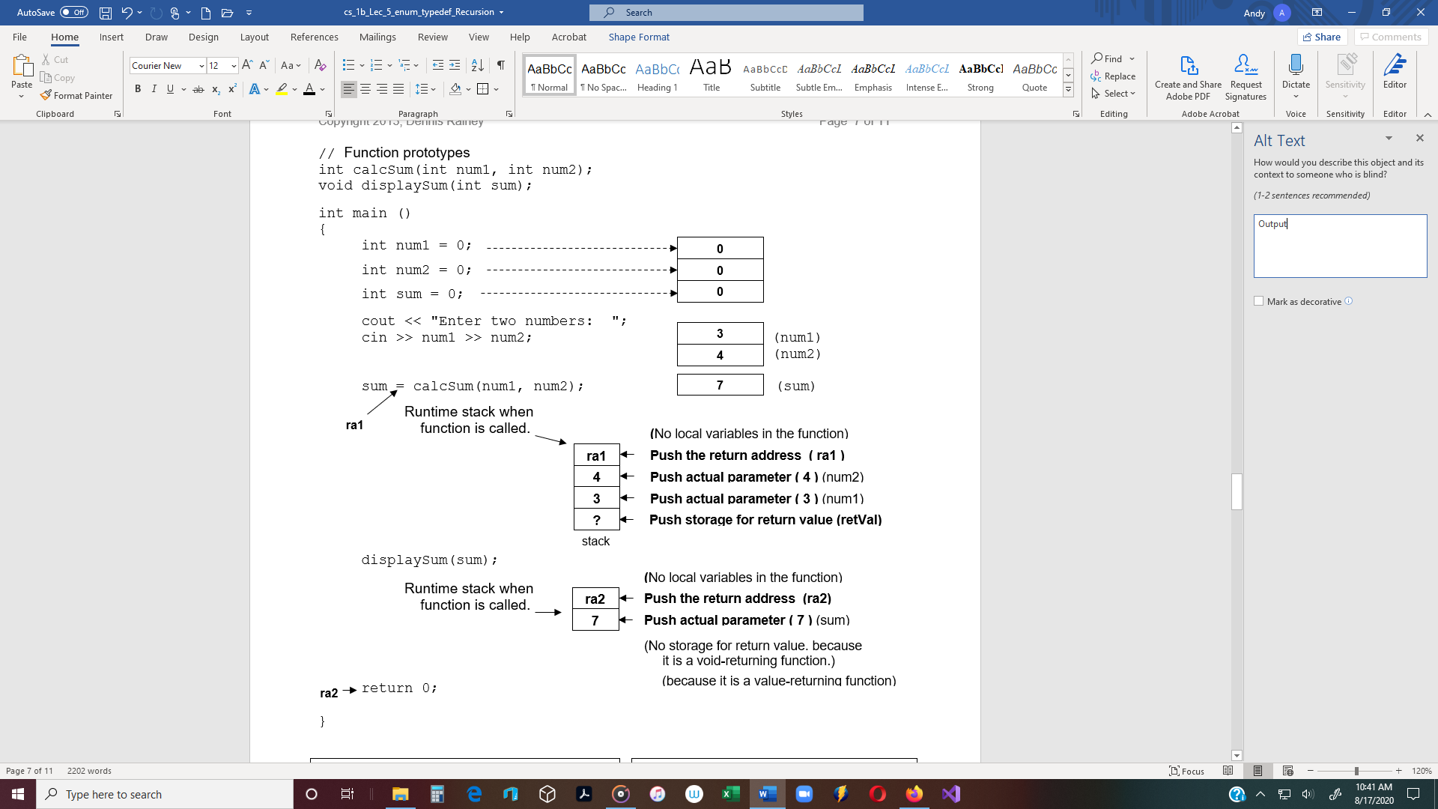

**// Function definition**

int calcSum(int num1, int num2)

{

return num1 + num2;

}

**// Function definition**

void displaySum(int sum)

{

cout << “The sum is” << sum;

}

**Recursive Functions** - A function that calls itself.

* **Recursive call** - A function call in which the function being called is the same as the

one making the call.

* + In other words, recursion occurs when a function calls itself.
* Recursion requires systems and languages that support dynamic memory allocation.
  + **Dynamic allocation** - Function parameters and local variables are not bound to

addresses until an activation record is created at runtime.

* **Direct recursion -** Recursion in which a function directly calls itself.
* **Indirect recursion -** Recursion in which a chain of two or more function calls returns to

the function that originated the chain.

Ex #1: This is a recursive function. It does not work, because it runs like an infinite loop,

continually displaying the message.

void showMessage()

{

cout << “This is a recursive function\n”;

showMessage();

} **Recursive call**

Problem with Ex #1 above - The program is like an infinite loop.

**Runtime stack** - When a function is called, temporary data is pushed on the runtime stack.

- The data is removed when the function is finished.

- Data on the stack from the first function call is not removed before the next

function is called.

- Data from the second function call is pushed on the stack on top of the first data.

- Data from the third call is pushed on top of the second, and so on…

Result: The stack grows until the computer eventually runs out of memory and the

program crashes.

Solution: Include code to control the number of times the function is called.

Ex #2: int times = 10;

void showMessage(int times)

{

if (times > 0)

{

cout << “This is a recursive function\n”;

showMessage(times - 1);

}

}

**Solving Problems with Recursion**

* A problem can be solved with recursion if it can be broken down into successive

smaller problems that are identical to the overall problem.

* Recursion can be a powerful tool for solving repetitive problems and an important

topic in upper-level computer science courses.

**Recursion** - Be careful when using recursion.

* Recursive solutions can be less efficient than iterative solutions.
* Still, many problems lend themselves to simple, elegant, recursive solutions.
* When recursion is not possible or appropriate, a recursive algorithm can be

implemented non-recursively by using a looping structure.

In general, a recursive function works like this:

1.) To use recursion, identify at least one case in which the problem can be solved

without recursion. This is called the **base case**.

- **Base case** - A non-recursive way out of the function.

2.) If the problem cannot be solved now, then the function reduces it to a smaller but

similar problem and calls itself to solve the smaller problem. (**recursive case**)

- By reducing the problem with each recursive call, the base case will eventually

be reached and the recursion will stop.

- **Recursive case** - Each recursive function call leads to a smaller case of the original

problem, which eventually leads to the base case.

**Two considerations, when using a recursive function:**

* + Ask if there is a non-recursive solution to the problem.
  + Each recursive function call should involve a smaller case of the original problem

thus leading to the base case. (making progress)

**Recursive Function** - countChars function.

This program demonstrates a recursive function for counting the number of times a

character appears in a string.

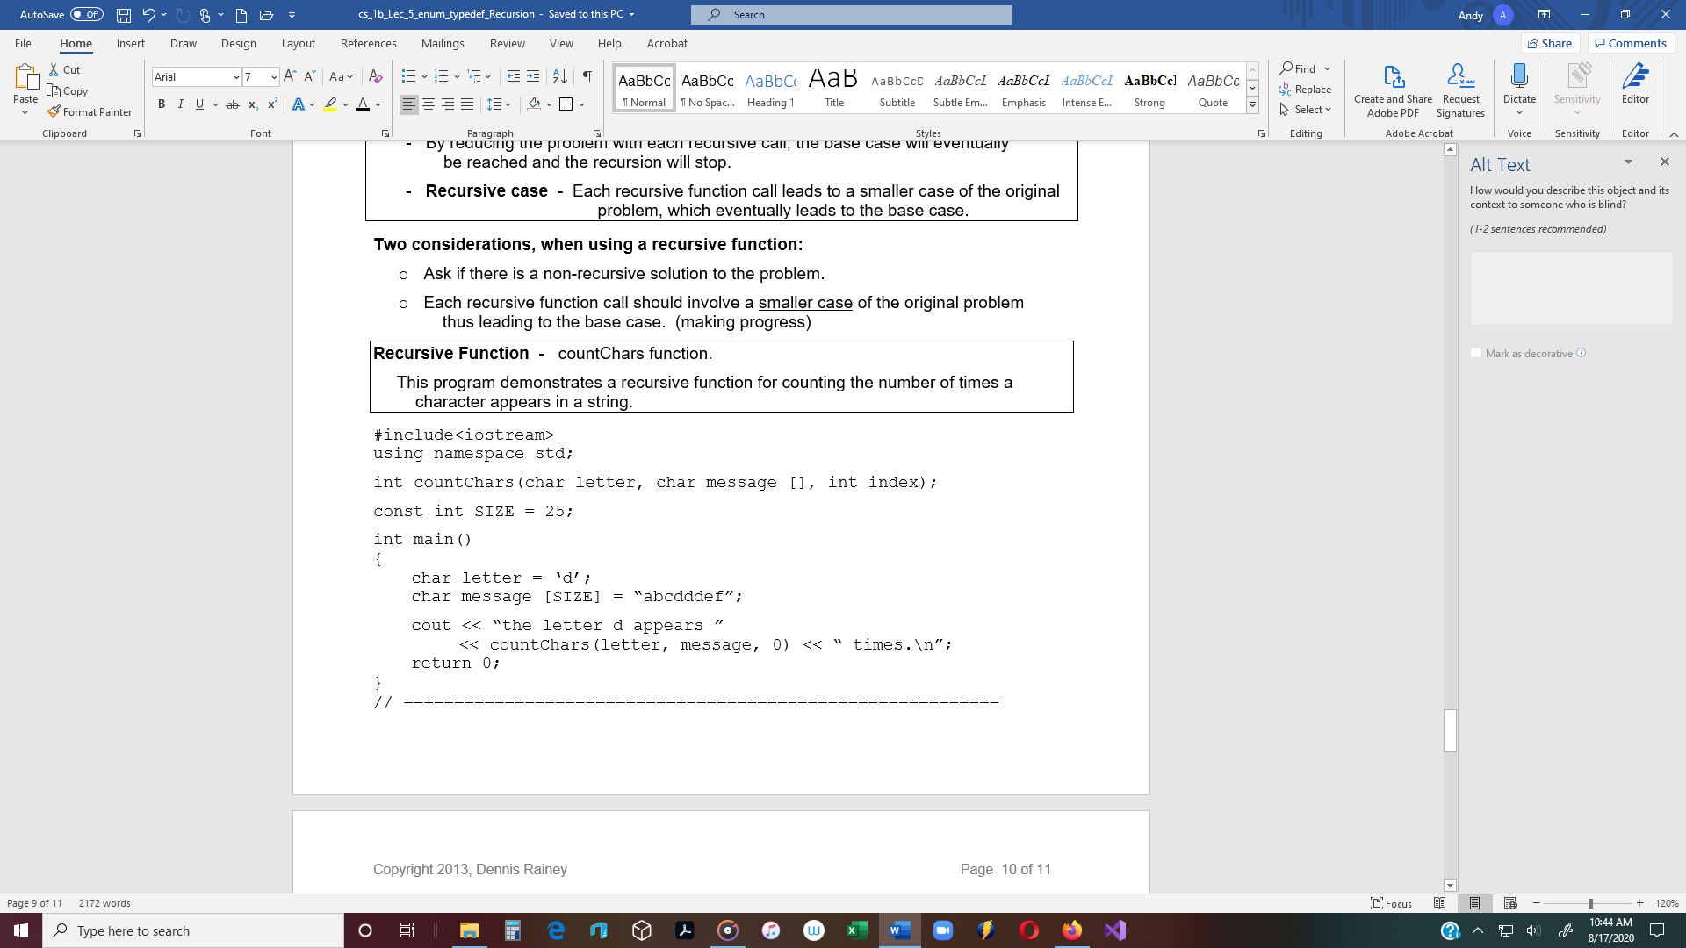

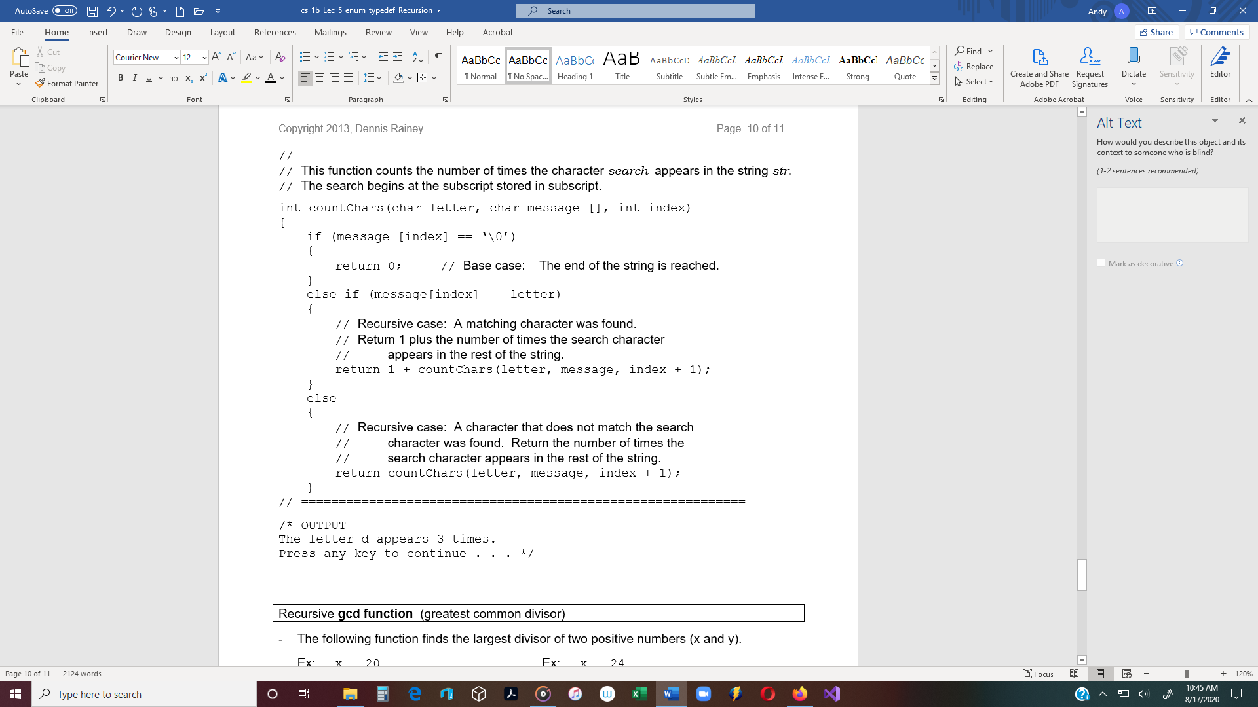

/* OUTPUT

The letter d appears 3 times.

Press any key to continue . . . */

